ELEC-2110

Electric Circuit Analysis

FROM: Jacob Howard

TO: Markus Kreitzer

DATE:

LAB SECTION: 002

Lab Title:

Lab subtitle

# **Introduction**

Summery… Explain what you are going to do……….

# **Exercise 1**

Explain exercise 1…

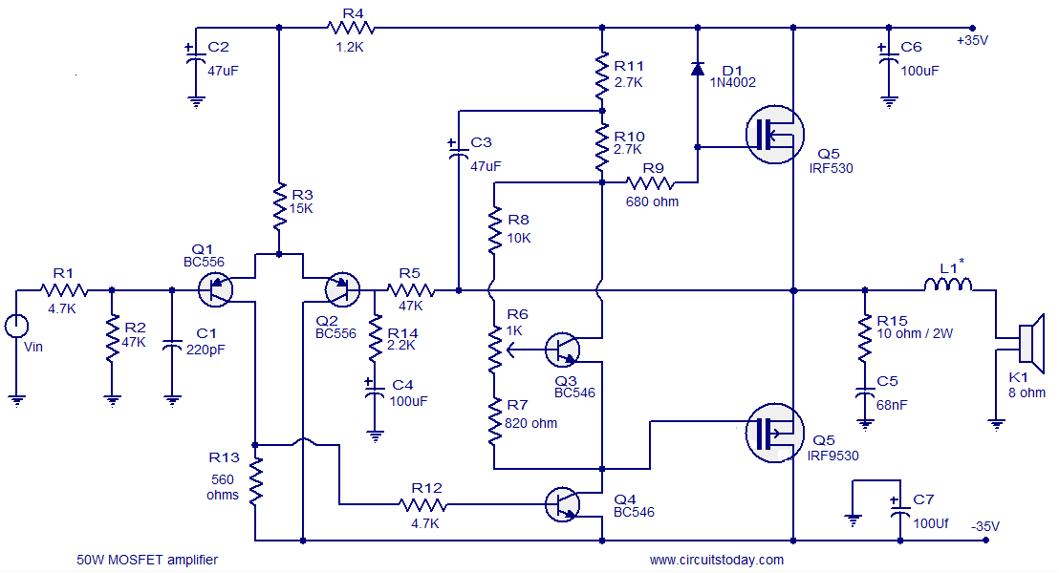

[This Photo](https://todayscircuits.blogspot.com/2011/06/50-watt-mosfet-amplifier.html) by Unknown Author is licensed under [CC BY-SA](https://creativecommons.org/licenses/by-sa/3.0/)

*Figure 1*

|  |  |  |
| --- | --- | --- |
| **Name** | **Value 1** | **Value 2** |
| Example | Of | A |
| Table | To use | In your Lab report |

*Table 1*

|  |  |  |  |  |  |  |  |  |  |  |  |  |  |  |  |  |  |  |  |  |  |  |  |  |  |
| --- | --- | --- | --- | --- | --- | --- | --- | --- | --- | --- | --- | --- | --- | --- | --- | --- | --- | --- | --- | --- | --- | --- | --- | --- | --- |
| *Example of code*   |  | | --- | | using System; | |  | using Microsoft.VisualStudio.TestTools.UnitTesting; | |  | using OpenQA.Selenium.Remote; | |  |  | |  | namespace CalculatorTest | |  | { | |  | [TestClass] | |  | public class BasicScenarios | |  | { | |  | protected const string WindowsApplicationDriverUrl = "http://127.0.0.1:4723/wd/hub"; | |  | protected static RemoteWebDriver CalculatorSession; | |  | protected static RemoteWebElement CalculatorResult; | |  | protected static string OriginalCalculatorMode; | |

*Code 1*

# **Conclusion**

Explain the lab conclusion… Explain what you did…….

Bibliography

[1] Some bibliography of the lab….